**Implementation of Minimum Spanning Tree using Kruskal Algorithm**

**INPUT:**

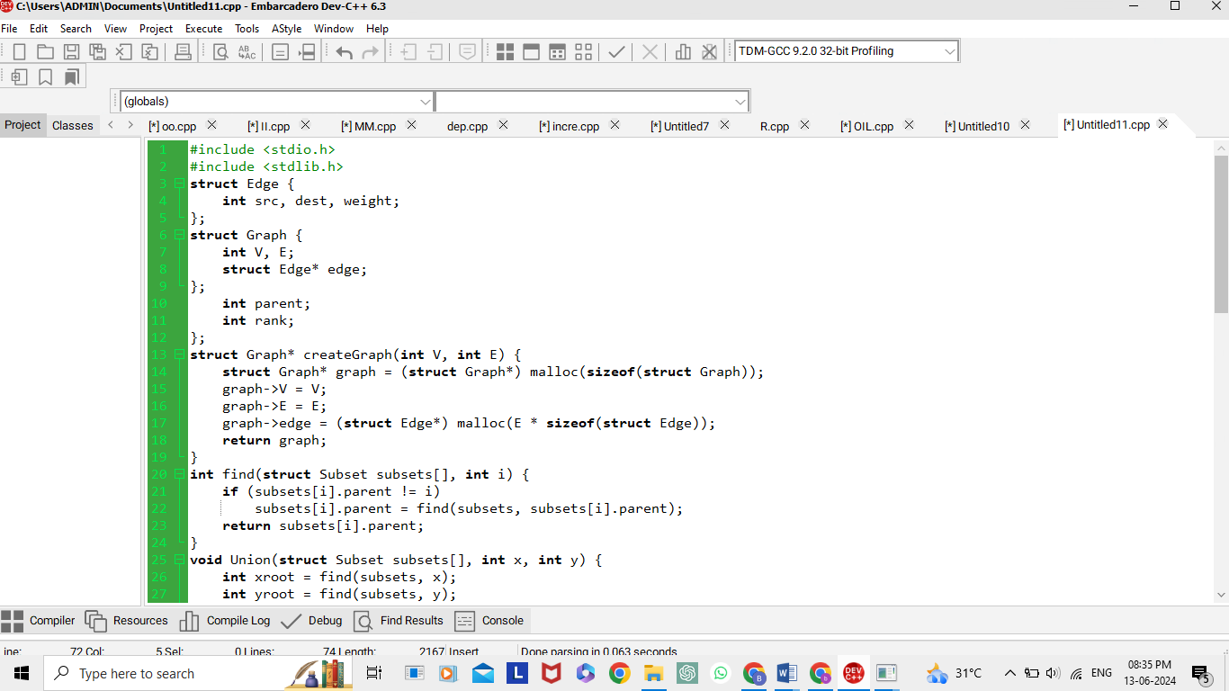

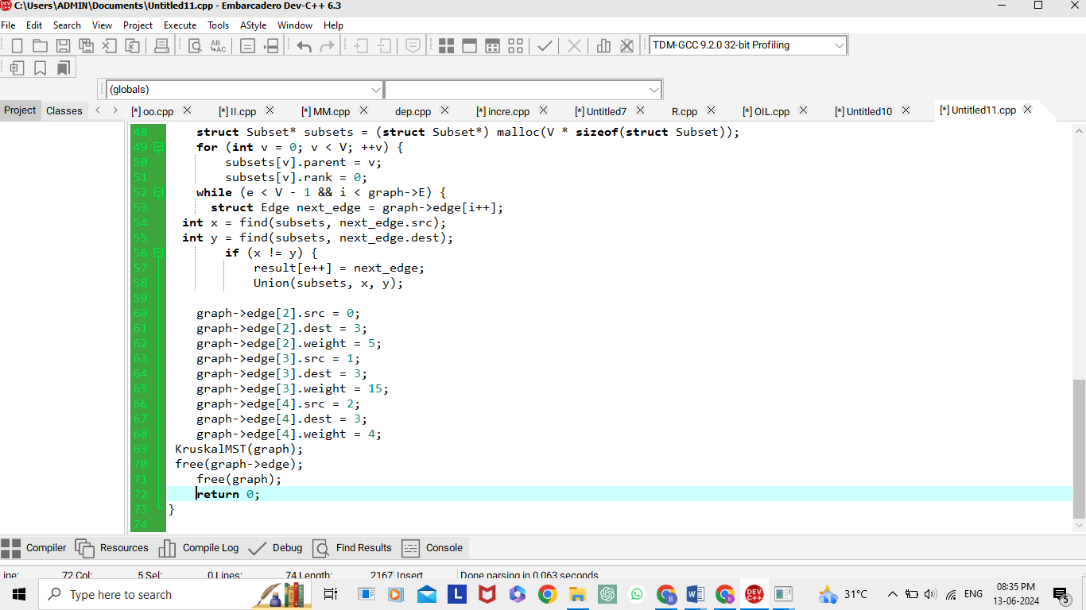

**OUTPUT:**

